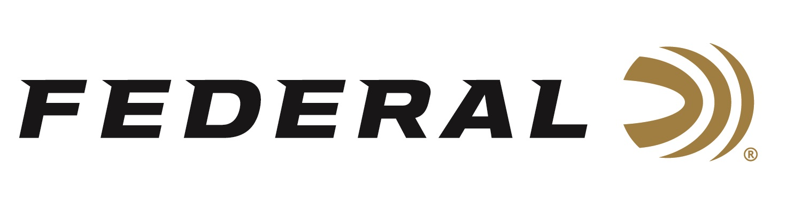

FOR IMMEDIATE RELEASE

Empower Yourself on “It’s Federal Season” Podcast

ANOKA, Minnesota – July 14, 2022 – Julie Golob guest hosts this episode of “It’s Federal Season” podcast and her guest is Craig Douglas of Shivworks. The two engage in an in-depth discussion on self-defense from both a mindset perspective and the mechanics of defending oneself should an unfortunate situation arise.

“Craig Douglas served twenty-one years in law enforcement,” stated Golob. “Craig has been teaching globally under the ShivWorks brand and has conducted coursework on entangled shooting skills in nearly 40 states and nine foreign countries. He has taught for federal, state, and local law enforcement agencies, and to three branches of the U.S. military and brings a lot to this important discussion.”

In the Tech Talk segment, Mike Holm, Federal’s Product Director for handgun ammunition goes deeper into the launch of the new 30 Super Carry. Specifically, Holm touches on the bullet options available in the new cartridge from Federal designed for self-defenders.

Episode #37 “Empower Yourself”
https://www.federalpremium.com/this-is-federal/podcast/

For this episode, besides listening on the Federal Premium website or Talk North podcast network, you can also subscribe to Federal Ammunition’s YouTube channel (https://www.youtube.com/user/federalpremiumammo) and tune in for the discussion.

Federal Ammunition can be found at dealers nationwide or purchased online direct from Federal. For more information on all products from Federal or to shop online, visit www.federalpremium.com.

Press Release Contact: JJ Reich
Senior Manager – Press Relations
E-mail: VistaPressroom@VistaOutdoor.com

About Federal Ammunition
Federal, headquartered in Anoka, MN, is a brand of Vista Outdoor Inc., an outdoor sports and recreation company. From humble beginnings nestled among the lakes and woods of Minnesota, Federal Ammunition has evolved into one of the world's largest producers of sporting ammunition. Beginning in 1922, founding president, Charles L. Horn, paved the way for our success. Today, Federal carries on Horn's vision for quality products and service with the next generation of outdoorsmen and women. We maintain our position as experts in the science of ammunition production. Every day we manufacture products to enhance our customers' shooting experience while partnering with the conservation organizations that protect and support our outdoor heritage. We offer thousands of options in our Federal Premium and Federal® lines-it's what makes us the most complete ammunition company in the business and provides our customers with a choice no matter their pursuit.

